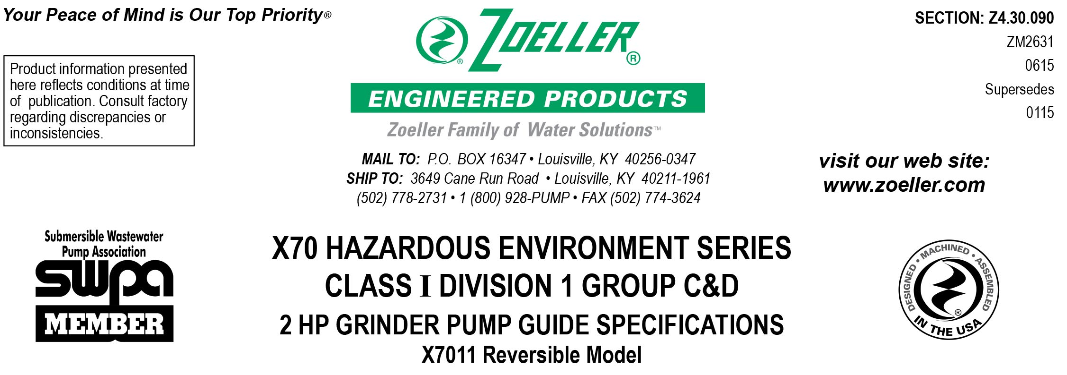
1.01 GENERAL
Contractor shall furnish all labor, material, equipment and incidentals required to provide _____ (QTY.) Model X7011 Reversible FM/CSA Listed grinder pump(s) rated for Class I Division 1 Group C&D environments as specified herein.

2.01 OPERATING CONDITIONS
Each submersible pump shall be rated at 2 H.P., _______ volts, _____ phase, _____ HZ., 3450 R.P.M.
The unit shall produce _______ G.P.M. at _______ feet of T.D.H.
The submersible pump shall be capable of handling sanitary sewage and grinding it into fine slurry enabling it to be pumped over long distances in pipelines as small as 1.25” in diameter. The pump shall be bi-directional as to allow the motor to operate in either direction, thereby enabling the cutter blades to change their rotational direction with each duty cycle. This action, initiated by the control panel, will extend the effective service life of the cutter mechanisms plus eliminate clogs and jams in the pump housing. Single directional designs shall not be considered equal. The pump shall have a shut-off head of 104 feet and a maximum flow of 45 G.P.M. at 5 feet T.D.H.

3.01 CONSTRUCTION
The centrifugal grinder pump shall be equal to the model X7011 submersible type as manufactured by Zoeller Engineered Products of Louisville, Ky. (800-928-7867) and listed by FM and CSA for hazardous environments. The castings shall be constructed of class 30 cast iron. The motor housing shall be finned and oil-filled to dissipate heat. Air-filled motors shall not be considered equal since they do not properly dissipate heat from the motor. All external-mating parts shall be machined and sealed with a Viton square ring. All fasteners exposed to the liquid shall be 300 series stainless steel. The motor shall be protected in the event of cord damage with a sealed junction chamber which will prevent moisture wicking into the motor housing. The motor shall be protected on the lower side with a tandem mechanical seal arrangement with each seal having a separate spring assembly. The oil-filled seal chamber located between the two mechanical seals shall contain 2 probes to detect seal leakage. The upper and lower ball bearings shall be capable of handling all thrust loads. The pump housing shall be of the concentric design thereby equalizing the pressure forces inside the housing, which will extend the service life of the seals and bearings. The pump shall have a SS lifting bracket.

4.01 ELECTRICAL POWER CORD:
The pump shall be supplied with 20’ (____ 35’ or ____ 50’ optional) of multiconductor power cord. It shall be SO type cord capable of continued exposure to the pumped liquid. Power cord shall be sized for the rated full load amp loading of the pump in accordance with the National Electric Code. Power cable shall enter into the junction box through a compression type-sealing gland. Water sealing and strain relief is separated. The entire junction chamber shall be sealed off from the motor housing by through wall terminals to protect the motor from moisture.

5.01 MOTOR:
The rated oil-filled motor with Class I Division 1 Group C&D construction shall be a Class F insulated NEMA B design rated for continuous duty. At maximum load, the winding temperature will not exceed 250 degrees F unsubmerged. Since air-filled motors are not capable of dissipating heat, they shall not be considered equal. Single-phase units shall have an integral thermal overload switch in the windings for protecting the motor. Start capacitors and relay shall be mounted externally from the pump in a panel within 50 feet of the pump location. Three phase units shall have a bimetallic thermal sensor and shall use magnetic starters with overload relays in the control panel for further protection.

6.01 BEARINGS AND SHAFT
Upper and lower ball bearings made of high carbon chromium steel shall be provided to prevent shaft deflection by withstanding all thrust and radial loads. The bearing system shall be designed to enable proper cutter alignments from shut off head to maximum load at 5 feet of TDH. The motor shaft shall be made of 416 SS and have a minimum diameter of 1.0”.

7.01 SEALS:
Pump shall have a dual mechanical seal configuration with the seals mounted in tandem. Each seal assembly having silicon carbide / carbon lower and carbon / ceramic upper faces with Buna-n elastomer and 316SS spring. It shall be equal to a Crane Type
21 configuration. Double seals with a common intermediate spring and lip seals shall not be considered equal.
Optional seal faces shall be
___Silicon carbide / carbon - ____ Upper
___Silicon carbide / silicon carbide - ____ Lower / ____ Upper

8.01 IMPELLER
The impeller shall be a fully balanced ductile iron vortex type (____ bronze optional) with pump out vanes on the back shroud to keep debris away from the seal area. It shall be keyed and bolted to the motor shaft. The impeller design shall be such that the G.P.M. capacity of the pump is the same regardless of which direction it is rotating. Single directional impellers are not considered equal.

8.02 CUTTER MECHANISM
The cutter and plate shall be constructed of 440 SS with a Rockwell C hardness of 55 - 60. The stationary cutter plate shall have specially designed orifices machined through it which enable the slurry to flow through the pump housing at an equalized pressure and velocity. The rotating “star” cutter design shall have double-sided cutting blades thereby increasing the number of cutting surfaces. The design of the plate and cutter allows the motor to rotate in either direction. Other cutter designs with tight clearances and those that grind on the circumference of the rotary plate shall not be considered equal.

9.01 PAINTING
The exterior castings of the pump shall be protected with green powder coated epoxy finish.

10.01 SUPPORT
The pump shall have cast iron support legs enabling it to be a freestanding unit. The legs will be high enough to allow solids and long stringy debris to enter the cutter assembly.
For those installations requiring a field assembled rail system:
____ Non-sparking rail system with pump suspended by means of a sealed pump plate attached to the pump. Rail and guide brackets
shall be brass. Rail pipes and lifting cables are to be provided by others.
____ SS intermediate stabilizer required for rail systems used where basin depths are greater than 12 feet.

For those “Outdoor” installations requiring a factory assembled basin package:
____ Simplex system with a ____” diameter by ____” depth basin.
____ Duplex system with a ____” diameter by ____” depth basin.

For those “Indoor” installations requiring a factory assembled basin package:
____ Simplex system with a ____” diameter by ____” depth basin.
____ Duplex system with a ____” diameter by ____” depth basin.

11.01 TESTING
Each pump shall be operated and tested in liquid during the production process. It shall be checked at its maximum running point for performance, amps, grounding, winding insulation, and water tightness.

____ An optional certified test based on the Hydraulic Institute or SWPA (Submersible Wastewater Pump Association) Test Standard
for submersible pumps.

____ Start up services at the job site by an authorized representative of Zoeller Engineered Products shall be required. Start-up
report form ZM1074 should be completed in the presence of the installers and returned to the Project Engineer or Zoeller Engineered Products.

12.01 WARRANTY
Standard warranty shall be 12 months from date of installation or 18 months from date of manufacture, whichever comes first.

